Name: _____________________ Date: _________________ Block: _____


Top Chef: Pasta Edition

Directions: You are the chef at a leading Italian restaurant, Ristorante D’Ottolini. In order to keep all your pasta shapes straight, you must devise a classification system for pasta shapes using a dichotomous key.

You will first give each pasta shape a scientific name. It should sound “Latinized” and be somewhat descriptive of the particular pasta shape. Remember, the genus must be capitalized and the species must be lowercase. After you have named your pasta shapes, create a branched diagram and then translate this diagram into a standard list using the method shown below.

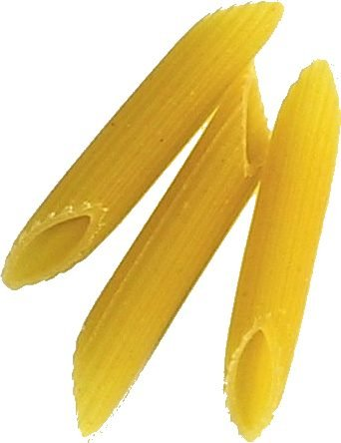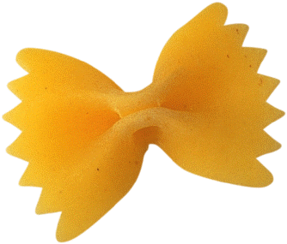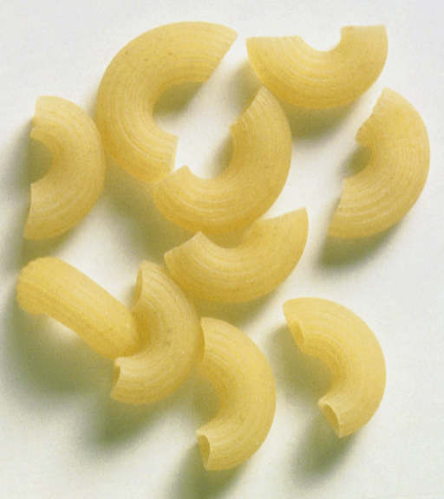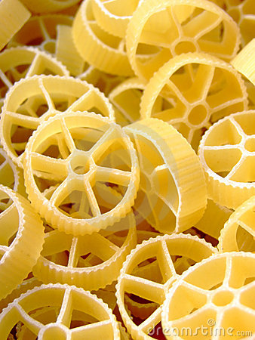

Pasta 1 Pasta 2 Pasta 3 Pasta 4

Branched Diagram:

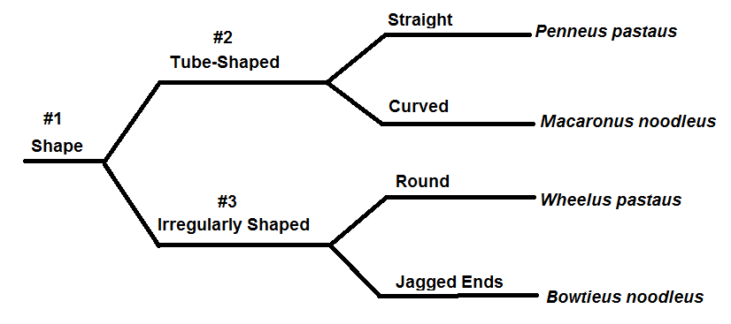
****Note: as in the diagram, number each step of the process so that you can easily make a numbered list!***
Numbered List:

1) a. If your pasta is tube shaped go to………………………………..………………………..Step 2
b. If your pasta is irregularly shaped, go to……………………………..………………….Step 3

2) a. If your pasta is straight, it is…...................................................Penneus pastaus
b. If your pasta is curved, it is……………………………………………….Macaronus noodleus

3) a. If your pasta is round, it is………………………………………………………Wheelus pastaus
b. If your pasta has jagged ends, it is……………………………………….Bowtieus noodleus

Now it’s your turn….prove that you are the top chef of Ristorante D’Ottolini!

Scientific Names: Create names for your pasta shapes in the table below. You may not use all of the rows!

Name | Description of Appearance

Branched Diagram: Draw a branched diagram like the one shown on the first page. Make sure to number each step so you can create a list.

Numbered List: Create a numbered list from your branched diagram. All pasta shapes should be included in your numbered list!

Reflective Paragraph: In a well-written 5-7 sentence paragraph (attached with a staple to this sheet), explain why biologists use dichotomous keys. Also, discuss whether or not you feel this is a good classification method, and describe which part of the creation process was most difficult for you and your partner.

